**Standard Operating Procedure (SOP):**

**SCHEMA DETECTION AND EVOLUTION IN SNOWFLAKE**

OBJECTIVE:

To establish a structured process for detecting and evolving database schemas in Snowflake, ensuring data consistency, compatibility, and smooth operations as the data model evolves over time.

SCOPE: This SOP covers the following key areas:

**Schema Detection**: Identifying changes in schema or columns.

**Schema Evolution**: Managing schema changes such as adding, altering, or removing columns.

**Change Management**: Documenting and deploying schema changes in a controlled and automated manner.

Load Sample CSV and JSON Files into the Internal Stage Location

USE DATABASE SCHEMA_CHANGE;

USE SCHEMA EMPLOYEE;

-- loaded csv and json in stg

SHOW STAGES;

LIST @"SCHEMA_CHANGE"."EMPLOYEE"."EMPLOYEE" ;

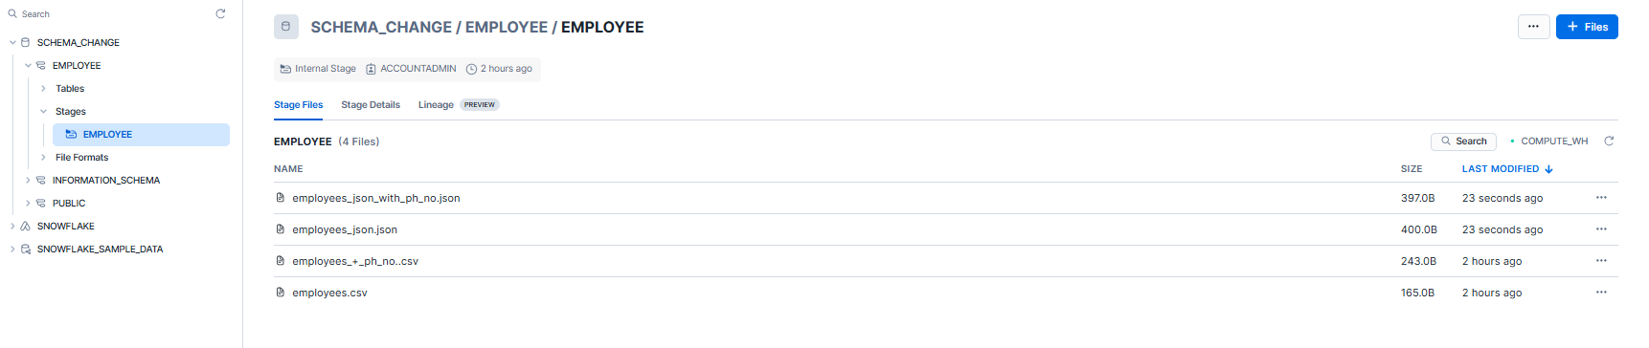

Here we loaded.

Case 1: CSV data

employees.csv: Table need to be updated with field phone number.

employees_+_ph_no..csv: Updated table with phone number field.

Case 2: Json data

employees_json: Table need to be updated with field phone number.

employees_json_with_ph_no: Updated table with phone number field.

**case 1**: CSV data.

Step 1: create file format.

CREATE OR REPLACE FILE FORMAT my_csv_format

TYPE = 'CSV'

FIELD_OPTIONALLY_ENCLOSED_BY = '"'

PARSE_HEADER = True

FIELD_DELIMITER = ',’ ;

Step 2: Schema detection (Infer schema)

create employee_table using infer_schema.

CREATE OR REPLACE TABLE employee_table

USING TEMPLATE (

SELECT ARRAY_AGG (object_construct(*))

FROM TABLE (

INFER_SCHEMA (

LOCATION=>'@"SCHEMA_CHANGE"."EMPLOYEE"."EMPLOYEE"/employees.csv’, FILE_FORMAT=>'my_csv_format' ) ));

In this important step is to use INFER_SCHEMA, if we use it no need to define structure it automatically creates.

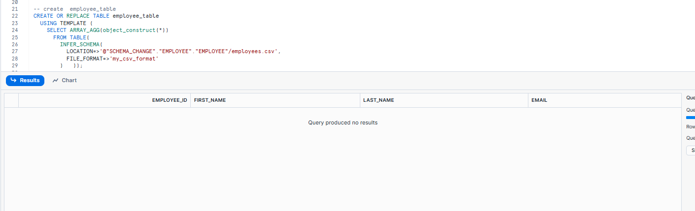

Step 3: Schema Evolution (Enable Schema Evolution).

-- check enable schema evolution on the table is Y or N

show tables.

|  |  |
| --- | --- |
|  |  |

In the above two tables for Employee table which we are using in **case 1** showing **N** in Enable Schema Evolution make it **Y** by running the below code.

-- enable schema evolution on the table to Y

ALTER TABLE employee table SET ENABLE_SCHEMA_EVOLUTION = TRUE;

Show tables:

|  |  |
| --- | --- |
|  |  |

Step 4: Copy data from stage.

-- load data into employee_table

COPY INTO employee_table FROM

@"SCHEMA_CHANGE"."EMPLOYEE"."EMPLOYEE"/employees.csv

FILE_FORMAT = (FORMAT_NAME= 'my_csv_format' , error_on_column_count_mismatch=false)

MATCH_BY_COLUMN_NAME=CASE_INSENSITIVE ;

In this important step is to use

error_on_column_count_mismatch=false and MATCH_BY_COLUMN_NAME=CASE_INSENSITIVE

using the above will easily append changes in the fields name or if new field found.

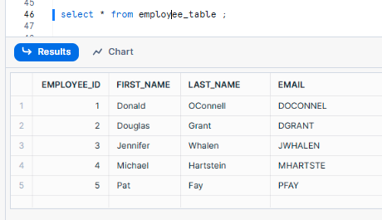

Step 5: New field phone number append to the same table.

-- load data into employee_table with phone number

COPY INTO employee_table FROM

@"SCHEMA_CHANGE"."EMPLOYEE"."EMPLOYEE"/employees_+_ph_no..csv

FILE_FORMAT = (FORMAT_NAME= 'my_csv_format' , error_on_column_count_mismatch=false )

MATCH_BY_COLUMN_NAME=CASE_INSENSITIVE ;

By running above code, the same table employee_table will append new field as shown below.

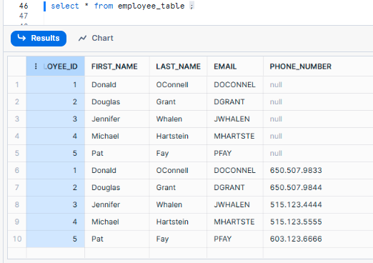

Data here loaded as incremental.

**case 2**: JSON data.

Step 1: create file format.

-- Create a file format that sets the file type as Parquet.

CREATE OR REPLACE FILE FORMAT my_json_format

TYPE = json,

STRIP_OUTER_ARRAY=TRUE,

date_format=auto,

time_format=auto,

timestamp_format=auto;

Step 2: Schema detection (Infer schema)

create employee_table_json using infer_schema.

CREATE OR REPLACE TABLE employee_table_json

USING TEMPLATE (

SELECT ARRAY_AGG(OBJECT_CONSTRUCT(*))

FROM TABLE(

INFER_SCHEMA(

LOCATION=>'@"SCHEMA_CHANGE"."EMPLOYEE"."EMPLOYEE"/employees_json.json',

FILE_FORMAT=>'my_json_format'

) ));

In this important step is to use INFER_SCHEMA, if we use it no need to define structure it automatically creates.

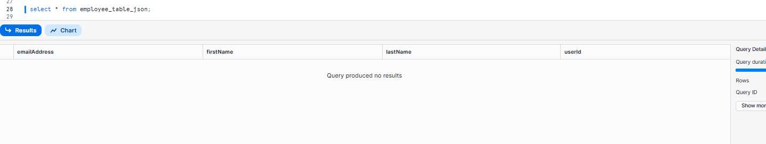

Step 3: Schema Evolution (Enable Schema Evolution).

-- check enable schema evolution on the table is Y or N

show tables.

|  |  |
| --- | --- |
|  |  |

In the above two tables for Employee table_jason which we are using in **case 2** showing **Y** by running the below code.

-- enable schema evolution on the table to Y

ALTER TABLE employee_table_json SET ENABLE_SCHEMA_EVOLUTION = TRUE;

Step 4: Copy data from stage.

-- Add data to the employee_table_json

COPY INTO employee_table_json

FROM '@"SCHEMA_CHANGE"."EMPLOYEE"."EMPLOYEE"/'

FILES=('employees_json.json')

FILE_FORMAT=my_json_format

match_by_column_name=case_insensitive

purge=true;

In this important step is to use

MATCH_BY_COLUMN_NAME=CASE_INSENSITIVE and purge=true;

using the above will easily append changes in the fields name or if new field found.

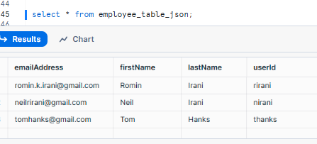

Step 5: New field phone number append to the same table.

-- update field to the employee_table_json

COPY INTO employee_table_json

FROM '@"SCHEMA_CHANGE"."EMPLOYEE"."EMPLOYEE"/'

FILES=('employees_json_with_ph_no.json')

FILE_FORMAT=my_json_format

match_by_column_name=case_insensitive

purge=true;

By running above code, the same table employee_table_json will append new field as shown below.

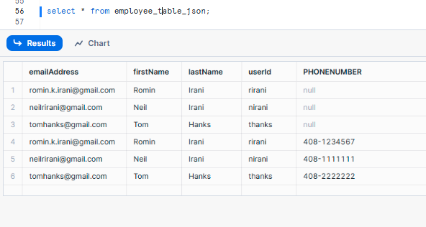

Data here loaded as incremental.